Japan in the eyes of the Swedish public:
a friendly and trusted partner
—
Åsa Malmström Rognes & Patrik Ström

Åsa Malmström Rognes
Head of the Asia Program at
the Swedish Institute of
International Affairs, UI.




Patrik Ström
Director of the European Institute of Japanese Studies at Stockholm School of Economics.

Introduction

The Asian barometer 2022 asked Swedes about their views on Japan, India and China. The results showed that overall they have a positive view of Japan, a fairly negative view of China and a mixed view of India. Swedish opinion on China and India has been examined in two previous briefs. This brief explores opinions about Japan in more detail.
The results show that the Swedish public has an overall positive view of Japan. It is seen as a developed country that is important internationally and takes its international responsibilities seriously. It is also a country that people want to visit and perceive as a country that Sweden could learn from.
A closer look at the results for Japan finds that older generations are slightly more positive towards Japan, as are people with a higher level of education. However, there are only small differences with respect to age, gender, education and political party affiliation. In the following, we attempt to understand how this view was formed and why it has endured even though Japan has been largely out of the news and is a country that comparatively few have visited. We trace this back to the 1980s, when Japan emerged as a leading producer of consumer goods, computer games, cars and motorbikes, and interest in all things Japanese increased considerably. While the production of consumer electronics is no longer dominated by Japanese firms, interest in Japanese culture and food has certainly persisted. Despite structural economic change, some of the household names in Japanese electronics and car production continue to have a strong connection with the Swedish public.
When examining the results, it is important to keep in mind that the survey was undertaken in late 2021, during the Covid-19 pandemic, when Japan had been closed to visitors since March 2020. There had been little media coverage of Japan in the years before the pandemic, the main exceptions being reporting on the Economic Partnership Agreement between Japan and the European Union, and the 2020 Tokyo Olympics which took place in the summer of 2021. There was positive coverage about the latter event and Swedish successes there, while a few articles questioned the wisdom of hosting the games while the pandemic was still ongoing. The media reporting after the conclusion of the games, however, often applauded Japan for being able to stage such a complex logistical endeavour. By contrast, media coverage of China was quite negative at the time. In the last quarter of 2021, the UN Framework Convention on Climate Change Conference of the Parties in Glasgow was in the news and the media coverage focused to some degree on China and India. Much less was written about Japan’s efforts, with the exception of minor references to the sustainability objectives of the Olympics, where Japan sought to showcase its latest contributions to building a greener economy. As was discussed in the Asian Barometer 2022 report these aspects might possibly have affected the results, as respondents may have contrasted the three countries when answering the questions.
The survey was the first of its kind and provides a snapshot of public opinion and knowledge of these three countries. The survey was undertaken in late 2021 as part of the annual SOM survey, to which 1 654 persons responded. In-depth analyses of the responses on China and India also sought to connect the answers to the public debate and foreign policy.

Figure 1 Views on Investments in Sweden by China, India and Japan
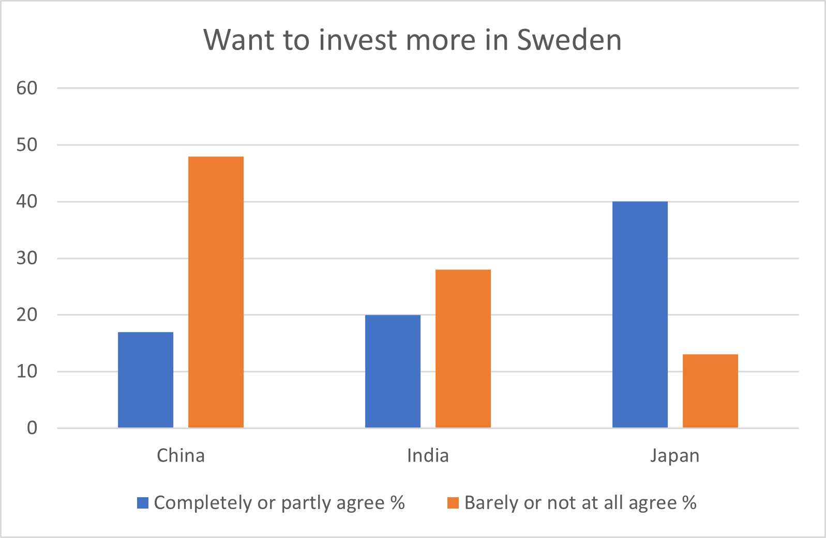

Source: UI Report 2:2022 The Asian Barometer

Japan in the public eye

In general, the survey results indicate that the Swedish public sees Japan as a developed country and a country that Sweden can learn from. It also views investment by Japan favourably, as is shown in figure 1. Going into more detail, older people are slightly more positive than younger people. People with a higher education tend to have a more positive view of Japan than those with fewer educational qualifications. More respondents with lower educational achievements are found among the people who responded “don’t know” to the statements. This would suggest that Swedish people with lower levels of education may feel unsure about their knowledge of Japan, which could explain why they also were slightly less positive about Japan as a partner country.

Another interesting aspect of the results is that the respondents with more positive views of the EU and of the US were more positive about investments from Japan. This is possibly because people who are positive about the EU are more inclined to see benefits from international investment and collaboration. The US alliance with Japan could also play a role in viewing investments from Japan in a positive light. There is little variation by party affiliation, but it is worthwhile noting that social democrats or left-leaning people are less positive about investments from Japan and less positive about Japan overall. This is somewhat surprising, since free trade and an open economy have been key characteristics of Swedish sentiment across the political spectrum for a long time.
The positive views may be partly attributed to Sweden’s long relationship with Japan. Sweden was among the first countries to establish diplomatic relations with Japan following the Meiji restoration. The Emperor has visited Sweden and there are good relations between the Swedish royal family and the imperial family. In 2018, 150 years of diplomatic relations was celebrated with exhibitions and high-level visits in both directions. In 2018, although all the major Swedish companies were represented in Japan, trade with Japan accounted for only 1.3 per cent of Sweden’s total trade. Thus, while relations are well-established and solid, Japan is a small trading partner for Sweden.
It could be argued that the Swedes’ positive views on Japan were largely formed in the 1980s, when Japanese consumer goods, computer games and cars were very popular in Sweden as fuel-efficient Toyotas became an alternative to the predominance of Volvos and Saabs. In addition, television sets produced by Panasonic and Hitachi were as good as – and cheaper than – German products, the Sony Walkman and its many copies were ubiquitous among teenagers and many Swedish youngsters played with Nintendo handheld and stationary consoles. In the 1980s, these and other Japanese brands became household names, there was increased interest in studying Japanese and learning about Japan more broadly, and more courses were offered by universities – the European Institute of Japanese Studies at the Stockholm School of Economics, which was inaugurated in 1992, being the prime example. This is a mainly privately funded institute that aims to provide education and research on Japanese business and its economy, as well as various outreach activities. An undergraduate course that combines international business studies with Japanese language learning was launched by the University of Gothenburg at about the same time. In the late 1990s, some of Sweden’s larger research funding bodies launched specific research programmes on Asia, in which Japan was a central focal point. In parallel, there was increased interest among university students in studying Japanese, which has been one of the most popular Asian languages taught at Swedish universities ever since. Several Japanese Nobel Prize laurates have also helped to secure at least limited media attention on Japan in Sweden over the years.
In the West more generally, there was a growing interest in Japanese Studies amid keen interest in learning more about Japanese business practices to understand how these companies had become globally competitive. Alongside this, there was increased interest in learning more about Japanese culture, literature and food. The 1980s was also the decade when Japan became known as a country with cutting edge technology, as perhaps best symbolised by its shinkansen “Bullet” trains. In this decade, Swedish media posted correspondents to Tokyo and there was much more in the news about Japan than any other Asian country. These factors could help to explain the answers to some of the questions in the survey, especially regarding Japan as a developed country that Sweden should cooperate with and learn from.
Japanese culture also became more widespread amid growing interest in the West. In the 1980s, Akira Kurosawa’s films and novels by authors such as Nobel Prize winner Yasunari Kawabata contributed to increased Western interest in Japanese cinema and literature, and there were more translations of literature into English and a growing interest in, for example, manga. Later, Japanese animated films set trends and became global hits, perhaps best exemplified by Spirited Away in 2001.
While few works are translated into Swedish, greater access to works translated into English has probably contributed to an interest in contemporary literature, such as the works of Haruki Murakami, and in manga, which are widely available in Sweden. Social media and streaming services have made all forms of popular culture more accessible. The ability to access Japanese films and series on services such as Netflix or HBO is an important channel.
With increased interest in Japan came a desire to visit the country. The impression that Japan is an expensive place to visit and the cost of travel have probably held tourism back, but this seems to be changing and more Swedes are keen to visit for a holiday (see figure 2). This resonates well with the results of the study, where there was a clear will among respondents to visit Japan. As the Covid-19 pandemic subsides, it is likely that tourism from Sweden to Japan will pick up further.

Figure 2 Views on visiting China, India and Japan

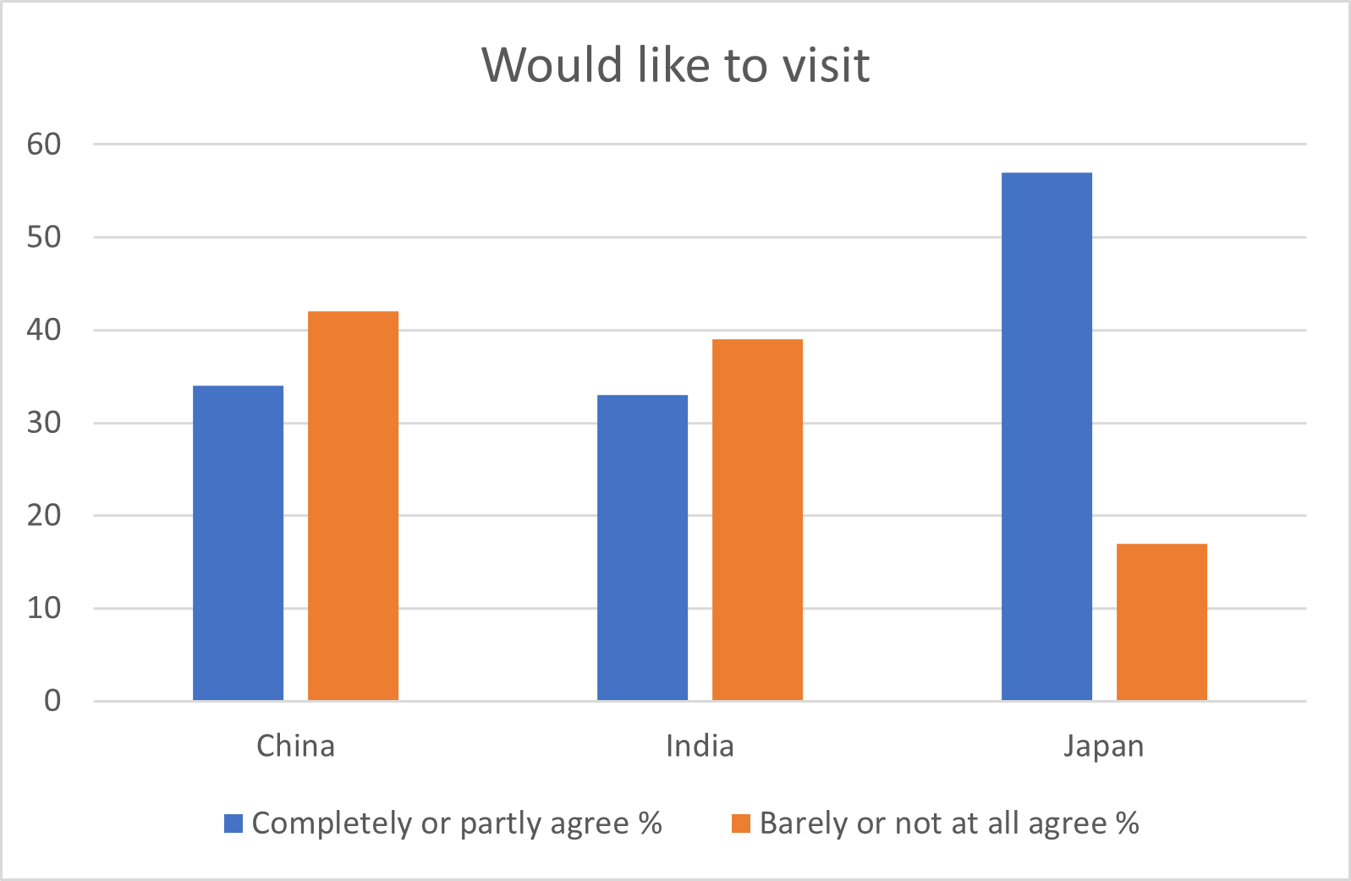

Source: UI Report 2:2022 The Asian Barometer

Japan in the media

While there were several Swedish journalists based in and reporting from Japan in the 1980s, from the 1990s the major newspapers and networks chose to base their correspondents in Beijing and/or Bangkok. The Japanese financial crisis in the early 1990s led to reduced interest in the Japanese economy just as interest in China and other Asian countries increased. There has consequently been much less coverage of Japan in Swedish media than of China for the past two decades. The prolonged economic stagnation in Japan contrasted with high growth in China. South Korean companies rapidly became global leaders in consumer electronics and Korean brands became household names. Large acquisitions of Swedish industry, such as the takeover of Volvo Cars by Geely, may have contributed to reduced coverage of Japan as media interest shifted to reporting on these growing economies.
In 2019, both an EU-Japan Economic Partnership Agreement (EPA) and a Strategic Partnership Agreement (SPA) entered into force. These agreements aim to facilitate trade and investments and provide the basis for extensive cooperation in a range of areas from climate change and security matters to the provision of infrastructure and collaboration in third countries. While these agreements are ground-breaking in some respects, such as EU food exports, they received little media coverage beyond the business press. It is likely that the positive impact of these agreements will be more visible in media reporting once the pandemic has receded.
At the beginning of the Covid-19 pandemic, there was extensive media reporting about the spread of the disease on a cruise ship in Japan, and the difficulties passengers faced returning to their home countries. This negative reporting gave way to far more devastating news about the pandemic in Europe and little more was written about Japan until the 2020 Tokyo Olympics, which took place after a 12-month delay, becoming the Tokyo 2020 +1 Olympics. In the sports pages, the news was largely positive as Swedes did well, while the news pages reported on Japanese who questioned why the games were being held while the pandemic was still raging. At the time the survey was undertaken, the most recent media reporting was about the Olympics.
In December 2018, ABB announced plans to sell its Power Grids Division to Hitachi Energy. The deal was concluded in July 2020. Hitachi paid about 100 billion SEK in the single biggest foreign investment in Sweden. Some concerns were raised about whether Hitachi intended to keep production in Ludvika and Västerås but expansion of activities has been strong in both locations. Since the deal was concluded, Hitachi has continued to expand and entered into new business deals that rely on locally sourced inputs. In 2023, Hitachi Energy reported one of Sweden’s largest export orders on record. Media reporting on labour union perceptions of Japanese ownership has also been very positive. Hitachi’s acquisition has thus had a positive impact on the regional business climate, similar to Volvo Geely’s impact on the car-making cluster in western Sweden.
While media coverage on the whole has been quite limited, the positive view of Japan as a high-tech economy with a long-term investment horizon seems to have been firmly established in the 1980s. The positive media coverage of Hitachi’s recent acquisition may well also have contributed to the positive views in the survey. Japanese culture has also found its own way to a Swedish audience, including through channels other than the mainstream media.

Politics and international relations

The statement about which responses were least positive was that: “Japan is a country that shows respect for democratic rights”. Just over 40% of respondents agreed with this statement, while 15% disagreed and 34% chose “don’t know”. The fact that one-third answered ”don’t know” suggests that the Swedish public feels that it has only a limited understanding of Japanese politics and society. This may be because little is written about Japanese society or its political system. An enduring image from business is the so-called salary man who works very long hours, as well as the fact that women rarely occupy senior positions in business, politics or the cultural sphere. The best-known business leaders, politicians and authors are all men, and a lack of gender equality may contribute to views on Japan. Furthermore, the dominance of the Liberal Democratic Party in the post-war era and consensus style politics could suggest limited democratic debate.
Barely half of the respondents agreed with the statement that Japan acts responsibly abroad and the proportion answering “don’t know” to this was also quite high. This answer could be related to the views on democratic rights, but without any follow-up questions it is difficult to understand what formed this opinion. It does demonstrate that greater knowledge of Japanese society more generally would be needed for the Swedish public to form an opinion.
Public opinion on Japan internationally contrasts with a 2016 survey of Europeans’ views on Japan, where 82% of respondents in France, Germany, Poland, Spain and the United Kingdom thought Japan contributed to stabilising the international economy, 74% that Japan helped to stabilise international order and 70% agreed that Japan provided solutions to global issues. The discrepancy might reflect different levels or types of media coverage and closer relations between Japan and, for example, the UK.

Conclusions

Perceptions of and opinions on Japan among the Swedish public are overwhelmingly positive and in line with a 2016 survey of European countries. It appears that the successful internationalisation of Japanese industry and the perception of Japanese society since the 1980s still have a strong foundation in Sweden. The positive answers in several areas show that this foundation could be developed further as the next phase of Swedish-Japanese relations is initiated as the EPA and SPA begin to bear fruit. Based on media coverage and business interest, Japan appears to be taking a more central position in the perception of Asian countries and moving out of the shadow of China in the view of the Swedish public. Large investments in Sweden by Japanese firms, in combination with an overall positive view of collaboration and the possibility of learning from Japan, would seem to be important factors in future. In parallel with a desire to visit Japan, it is likely that more Swedish people will learn more about contemporary Japanese society. However, more needs to be done to explain the functioning of Japanese society and the role Japan is seeking to play on the global political stage.

Bibliography
Affärsvärlden, 30 September, 2022, ”ABB säljer resten av [power grids till] Hitachi Energy för nästan 19 miljarder” [ABB to sell the remainder of power grids unit to Hitachi Energy for 19 billion SEK]

Brief No 3:2022 Få skillnader i svensk folkopinions syn på Kina, Nationellt kunskapscentrum om Kina UI [Few differences in Swedes views of China]

Dagens Industri, 17 October 2022, “Nybyggarglöd och framtidstro” [Faith in the future]
Dagens Industri, 22 May 2023, “Efter 147 miljardersaffären – Ludvika rustar för supertillväxt” [Ludvika prepares for supergrowth after the 147 billion deal]

Dagens Nyheter 20 July 2021, ”Tokyo håller andan – OS-bubblan kan spricka när som helst” [Tokyo holds its breath – the Olympic bubble can burst]

Dagens Nyheter,31 July, 2021, ”Historisk svensk succé i diskus: OS-guld till Ståhl och silver till Pettersson” [Historical Swedish success in the discus throw: Olympic gold to Ståhl and silver to Pettersson]

Delaryd, B. (1989). I Japan är kunden kung. Stockholm: Svenska Dagbladet

Expressen, 3 August, 2021, ” OS 2021 -Svensk succé i hoppningen, alla felfria” [Equestrian success in the Olympics]

Expressen, 8 August 2021, ”Sverige slog målet – tog nio medaljer” [9 Olympic medals – more than anticipated]

E-kuriren, 24 juni, 2021, ”Japans kejsare orolig för smitta under OS” [Japan’s Emperor is worried about Covid during the Olympics]

Fornander, K. (1991). Japan: reseberättelser och adresser. Stockholm: Norstedt.

Hufvudstadsbladet, 21 July 2021, ”Tokyo – ett OS mot alla odds” [Tokyo Olympics - against all odds]

Japan Times, 5 July 2018, “2020 Tokyo games aim to take big step toward carbon free society”
Johnson, C. (1986), MITI and the Japanese Miracle : the Growth of Industrial Policy Tokyo: Tuttle Books

Ministry of Foreign Affairs Japan (2016), An Image of Japan in Five European Countries (report).

Okimoto, D. (1989), Between MITI and the Market : Japanese Industrial Policy for High Technology. Stanford, Ca.:SUP

Svenska Dagbladet, 17 December 2018, ”ABB säljer Power Grids till Hitachi” [ABB to sell Power Grid unit to Hitachi]

Sveriges Radio Ekot, 1 July, 2020,” Hitachi huvudägare av ABB Power Grids - facket positivt” [The union is positive to Hitachi as new owner of ABB Power Grid]

UI Brief 11:22 The Swedish Publics’ View of India: an Ambivalent Picture.

UI Report 2:2022 The Asian Barometer
Wolferen, K. van. (1989), The Enigma of Japanese Power. London: Macmillan

About UI
Established in 1938, the Swedish Institute of International Affairs (UI) is an independent research institute on foreign affairs and international relations. Any views expressed in this publication are those of the author. They should not be interpreted as reflecting the views of the Swedish Institute of International Affairs. All manuscripts are reviewed by at least two other experts in the field. Copyright of this publication is held by UI. You may not copy, reproduce, republish or circulate in any way the content from this publication except for your own personal and non-commercial use. Any other use requires the prior written permission of UI.

UI Report 2:2022 The Asian Barometer
Brief No 3:2022 Få skillnader i svensk folkopinions syn på Kina, Nationellt kunskapscentrum om Kina, UI [Few differences in Swedes views of China] and UI Brief 11:22 The Swedish Publics’ View of India: an Ambivalent Picture.
Ekuriren, 24 June 2021, ”Japans kejsare orolig för smitta under OS” [Japan’s Emperor is worried about Covid during the Olympics] ; DN 20 July 2021, ”Tokyo håller andan – OS-bubblan kan spricka när som helst” [Tokyo holds its breath – the Olympic bubble can burst]; Hufvudstadsbladet, 21 July, 2021, ”Tokyo – ett OS mot alla odds” [Tokyo Olympics - against all odds]; Dagens Nyheter,31 July, 2021, ”Historisk svensk succé i diskus- OS-guld till Ståhl och silver till Pettersson” [Historic Swedish success in the discus throw: Olympic gold to Ståhl and silver to Pettersson] ; Expressen, 3 August 2021, ” OS 2021 -Svensk succé i hoppningen, alla felfria” [Equestrian success in the Olympics].
See for example Japan Times, 5 July 2018, “The 2020 Tokyo games aim take big step toward carbon free society“
Brief No 3:2022 and UI Brief 11:22
A range of books that became standard texts on Japan were published, e.g. MITI and the Japanese Miracle : the Growth of Industrial Policy ; The Enigma of Japanese Power, and Between MITI and the Market : Japanese Industrial Policy for High Technology, and in Swedish for example Delaryd, B. (1989). I Japan är kunden kung. Stockholm: Svenska Dagbladet and Fornander, K. (1991). Japan: reseberättelser och adresser. Stockholm: Norstedt.
Dagens Nyheter 20 July 2021, ”Tokyo håller andan – OS-bubblan kan spricka när som helst” [Tokyo holds its breath – the Olympic bubble can burst] ; Expressen, 8 August 2021, ”Sverige slog målet – tog nio medaljer” [9 Olympic medals – more than anticipated]
Svenska Dagbladet, 2018-12-17, ”ABB säljer Power Grids till Hitachi” [ABB to sell Power Grid unit to Hitachi] ; Affärsvärlden, 30 September, 2022, ”ABB säljer resten av [power grids till] Hitachi Energy för nästan 19 miljarder” [ABB to sell the remainder of power grids unit to Hitachi Energy for 19 billion SEK]; Sveriges Radio Ekot, 1 July, 2020, ”Hitachi huvudägare av ABB Power Grids - facket positivt” [The union is positive to Hitachi as new owner of ABB Power Grid]
Dagens Industri, 22 May 2023, “Efter 147 miljardersaffären – Ludvika rustar för supertillväxt” [Ludvika prepares for supergrowth after the 147 billion deal]
Dagens Industri, 17 October 2022, “Nybyggarglöd och framtidstro” [Faith in the future]
Ministry of Foreign Affairs Japan (2016), An Image of Japan in Five European Countries.

